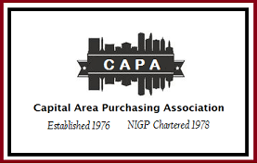

P.O. Box 26821
Richmond, VA 23261
www.capavirginia.org

2021 CAPA Membership Group Invoice Request Form

Group/Agency: ___ _______________________________________________________________
Group/Agency Administrator: _ _____________________________________________________
(Person Responsible for Billing)
Title: _ __________________________________________________________________________
Address: _ _______________________________________________________________________
Telephone: __ _____________________________ Fax: _ ___________________________
Administrator Email: __ ____________________________________________________________
(Person Responsible for Billing)
Groups of 5-9 members will receive a 5% Discount; Groups of 10 or more will receive a 10% Discount.
A link and an invoice will be sent to administrator to make payment online for memberships, or if you prefer to pay by phone, email the Treasurer to contact you.

Member Names to Add to Group Invoice: (If more than 10 members, add more lines to form)
NON-NIGP  $45.00 | NIGP  $40.00  (NIGP Memberships will be verified). | Full Name  (If a new member, will need full name, title, email and phone)  If additional space is needed, submit on another form.

*Please email this completed form to the CAPA Treasurer @ treasurer@capavirginia.org.

